# Corba

1. Java Project
2. IDL File
   1. New 🡪 File.

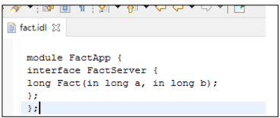

1. IDLJ File
   1. Run 🡪 External Tools 🡪 External Tools Configuration.
   2. Location: C:\Program Files\Java\jdk1.8.0_111\bin\idlj.exe
   3. Argument: -td src -fall fact.idl

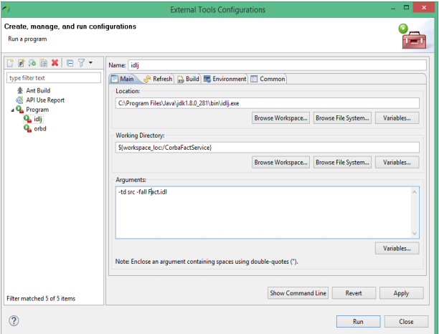

* 1. Run.
  2. RightClick and Refresh Workspace.

1. Create Packages, Client and Server
   1. Make class in each.

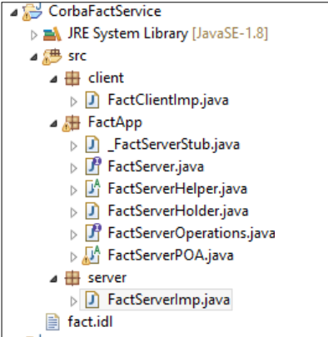

1. Write Client and Server Code.
2. ORBD File
   1. Run 🡪 External Tools 🡪 External Tools Configuration.
   2. Location: C:\Program Files\Java\jdk1.8.0_111\bin\orbd.exe
   3. Argument: -ORBInitialPort 1050 -ORBInitialHost localhost
3. Run Configurations
   1. Run 🡪 Run Configurations 🡪 Java Application.
   2. One for Server, One for Client.
   3. Arguments for both: -ORBInitialPort 1050 -ORBInitialHost localhost

# SOAP

========== Install Tomcat Server if not installed ==========

1. Create Java Project
2. Add Tomcat v7.0 Server to your project.
3. Create a package in src, and name it com.
   1. Project 🡪 src 🡪 com

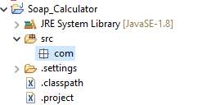

1. Create a class inside com.
   1. Project 🡪 src 🡪 com

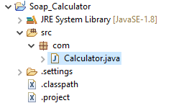

1. Create your function in the class.
2. Right Click on your class and Create Web Service.

# REST

1. New Spring Boot Project